CORONAVIRUS STATEMENT
Date: - 16TH March 2020
As a Supplier of Manpower, we understand the importance of keeping the services to the properties we work within operating so that there is as little disruption to businesses as reasonably possible.
We are also mindful that we should not overreact and cause panic, and will seek advice from government and local authorities, along with other experts, who can advise on the appropriate action to take at the right time. Please be aware, as with public services, acting may not be necessary until the UK Chief Medical Officer instructs.
Although each location we work in we believe is assessed on an individual basis, as a Company we would be taking steps try to ensure that adequate resources are made available to our staff so that back-up is provided where needed in the event of an outbreak.
We believe discussions between Clients, tenants, contractors, visitors and ourselves are important in ensuring any spread is minimised, and as part of our Business Continuity Management (BCM) where appropriate we will assist and pass on our procedures which can include the following:
- Staff are advised to inform Management if they believe they have or will be in contact with anyone that has travelled from affected areas or have displayed any symptoms.
- Staff are reminded to inform us of any Travel arrangements to affected areas.
- Site staff will be instructed not to attend site if displaying any symptoms.
- Individual site procedures will be put in place so that Clients, tenants, key personnel can be contacted in the event of a positive diagnosis to enable all to implement their own BCM procedures.
- Staff are reminded to maintain Hygiene regularly by washing hands.
- We would advocate that the provision of hand sanitizer gel dispensers may be placed within receptions and/or toilet areas, along with signage displayed to encourage use.
Further guidance and advice to assist all in formulating their own procedures can be found at: https://www.gov.uk/guidance/wuhan-novel-coronavirus-information-for-the-public

Regards
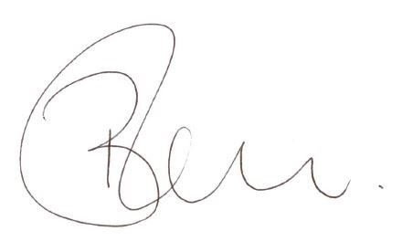
Neil Barham - Managing Director

